Classification

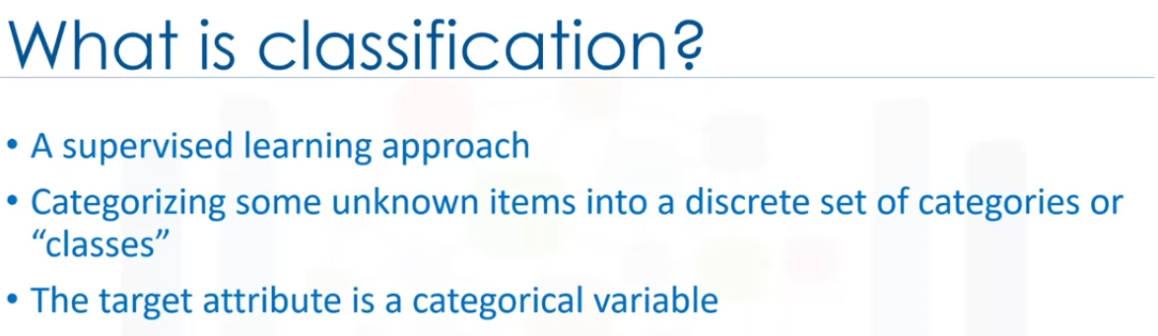

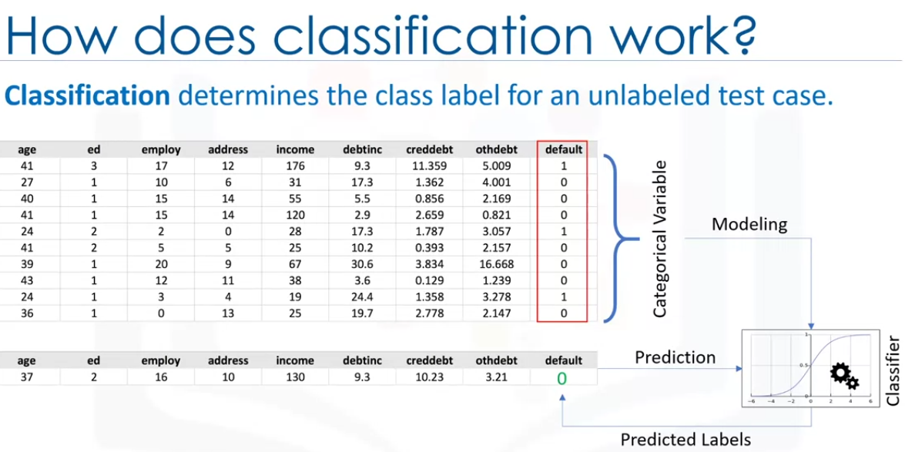

Given a set of trainig data points along with traget labels. the classification determines the class label of an unlabeld test case.

Lets see an example:

A good classification example is a loan default prediction.

Suppose a bank is concernedabout the potential for loans not to be repaid?

If the previous loan default data is used, the model can predict of a new customer will default the payments or not based on thedata collected.

The abive ckassifier is forbinary classification.

We could build classification for binary classification(which predicts one of two outcomes) or for muti classifications(can predict one of multiple values.).

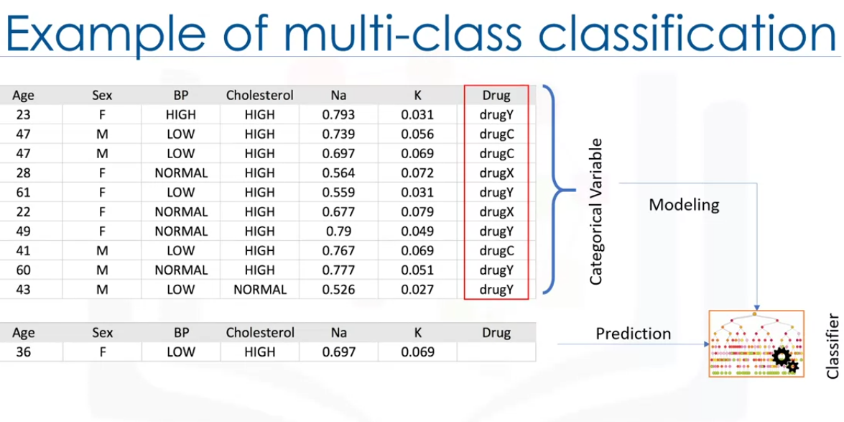

In the above exampele we can see there are different drugs available and based on symptoms the classification model can predict which drug to provide to the patient

Classification has a lot of business usecases. like

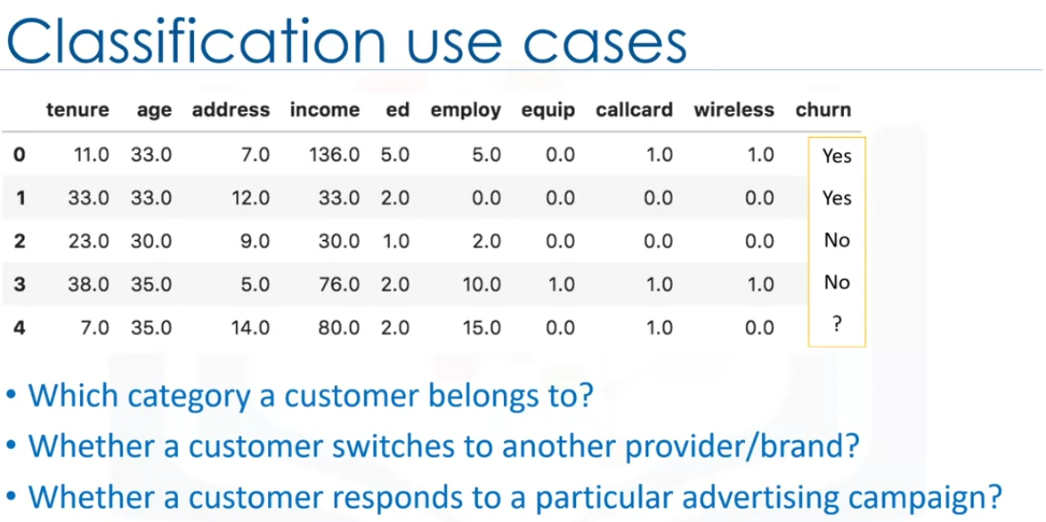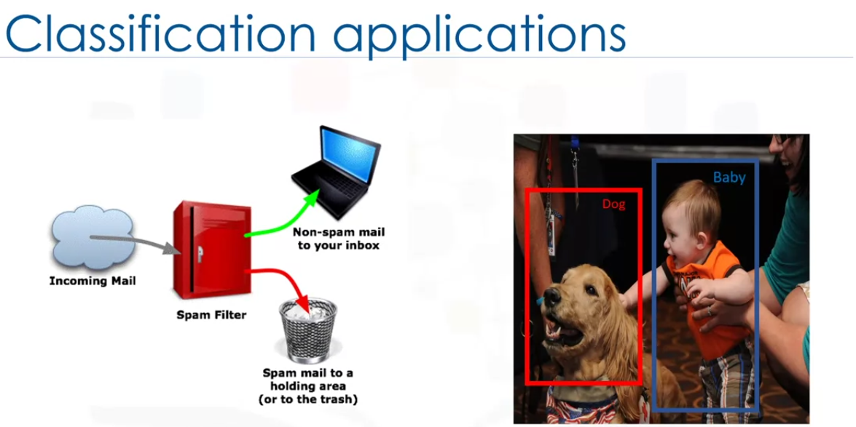

Classification has various applications in various industries.

Many problems can be represented as relationship between features and target variables. Especially when labeled data is available.

This privides a broad range of applicability for classification.

It can be used of speach recogniztion, email filtering, handwriting recognition, object recognition, biometric identification, document classification,

The following are the different classification algorithms in ML.

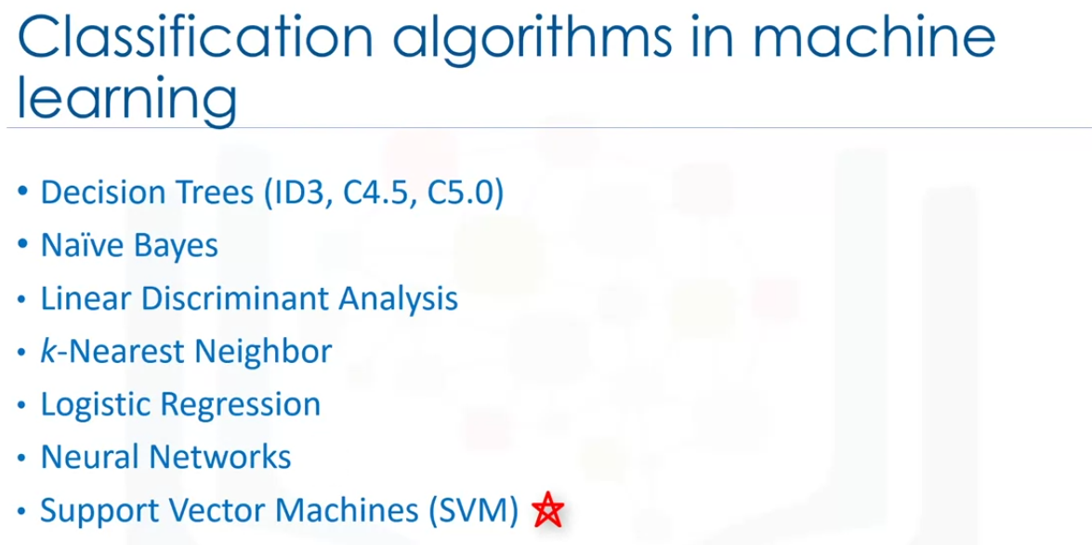

nearest Neighbour

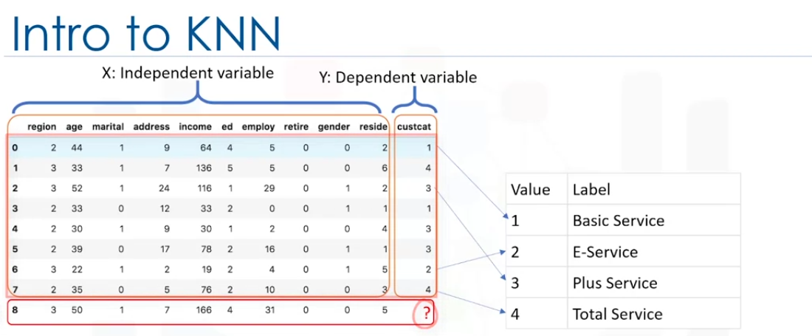

Imagine a telecom community has categorized customers into 4 groups.

If demographic data can be used to predict group membership then the company can customize offers for individual pperspective customers.

This is a classification problem.

Given a dataset with predefined labels, we need to predict the labels of unknown record.

We can use the colums region, age, marital status to predict usage patterns.

The taget column has 4 possible values shown in the image above.

We need to build the classifier.

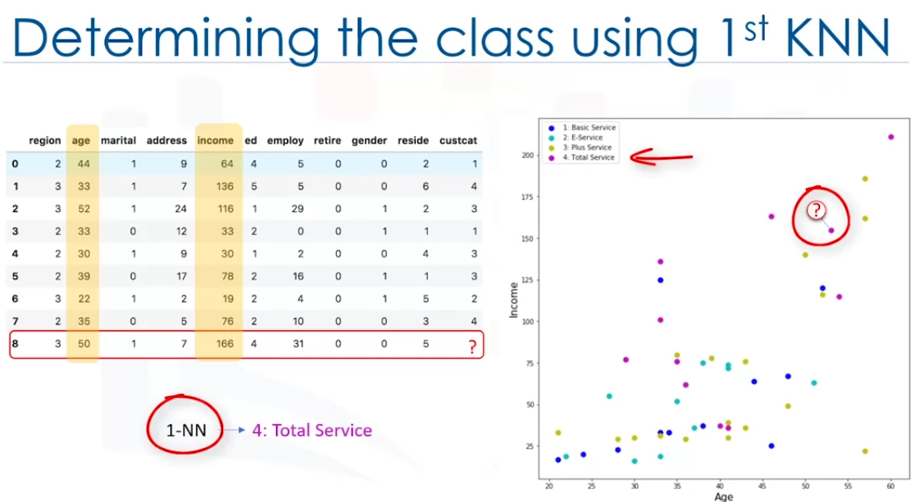

Let use age and income for this example.

Then plot the customers based on their grop membership.

Now for the unknow customer can we find the class ?

Can we find it by the closest cases and assign the same label to our new customer?

Can we say probably the customer belong to grough 4 Total service because its nearest neighbour belongs to Group 4?

Yes, we can. In fact it is the first nearest neighbour.

Is this enough insight to group the customer to group 4?

It might be a poor judgment. Especially if the 1st nearest neigbor is a very specific case or an outlier.

Now instead of choosing 1st nearest, lest choose 5 of them and ger the majority vote to define the group .

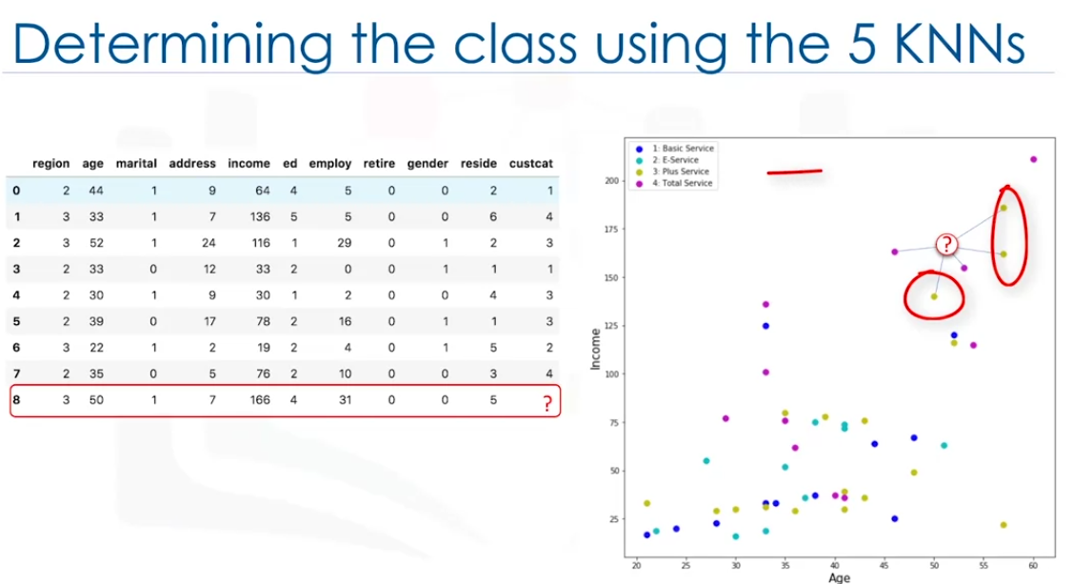

We can see that the group 3 has the highest votes.

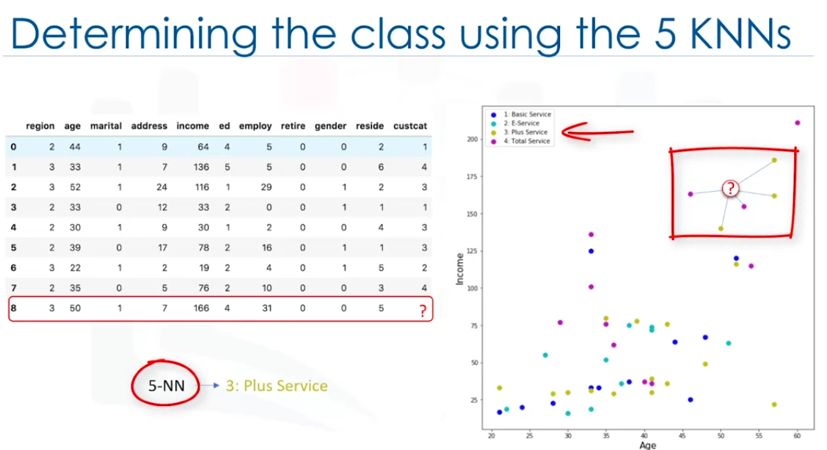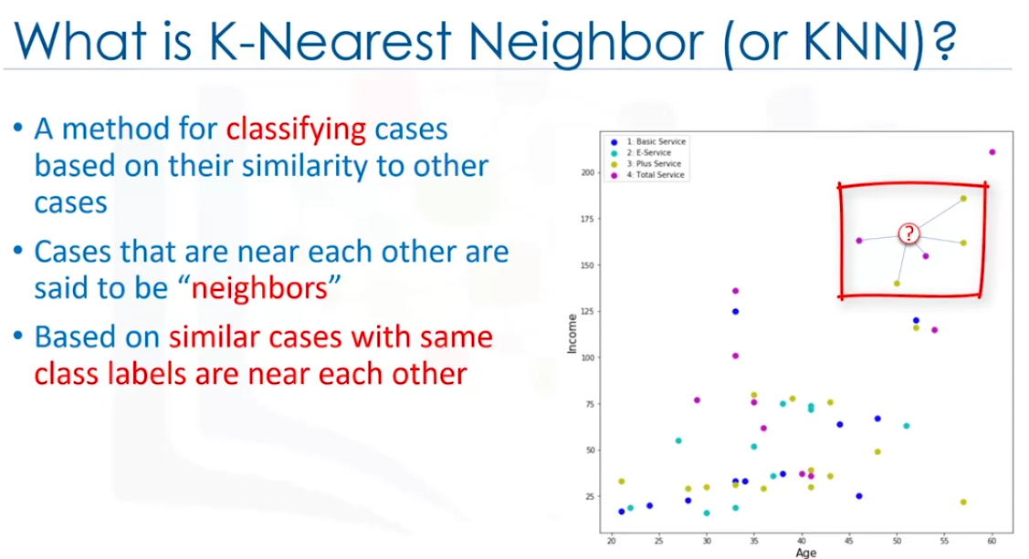

The distance between two points can be calculated in different ways, for example using Euclidean distance.

Lets see how it works:

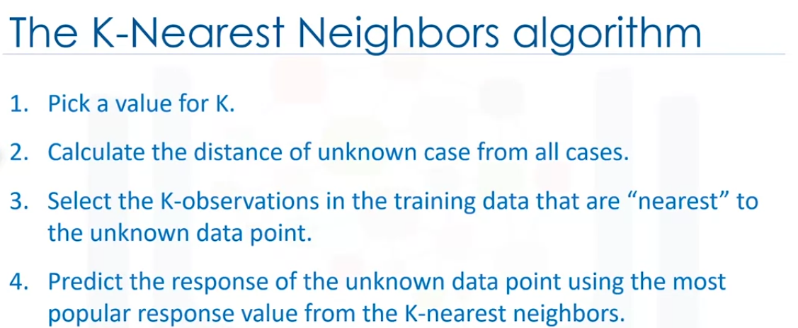

There are 2 parts in this algorithms that might be a bit confusing.

First, how to select the correct k value

Second, How to compute the similarity between cases.

lets see how to calculate the similarities first:

Assume we have 2 customers and they have one feature : age.

We can use Minkowski distance to calculate the distance of these 2 customers

It is indeed Euclidean distance

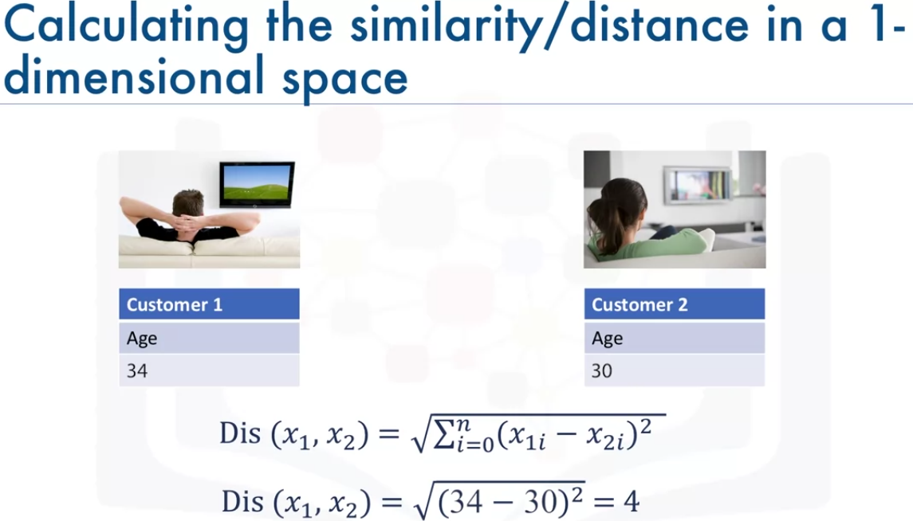

What if we have more than 1 feature? For example : ahe and income

We can use the following calculation

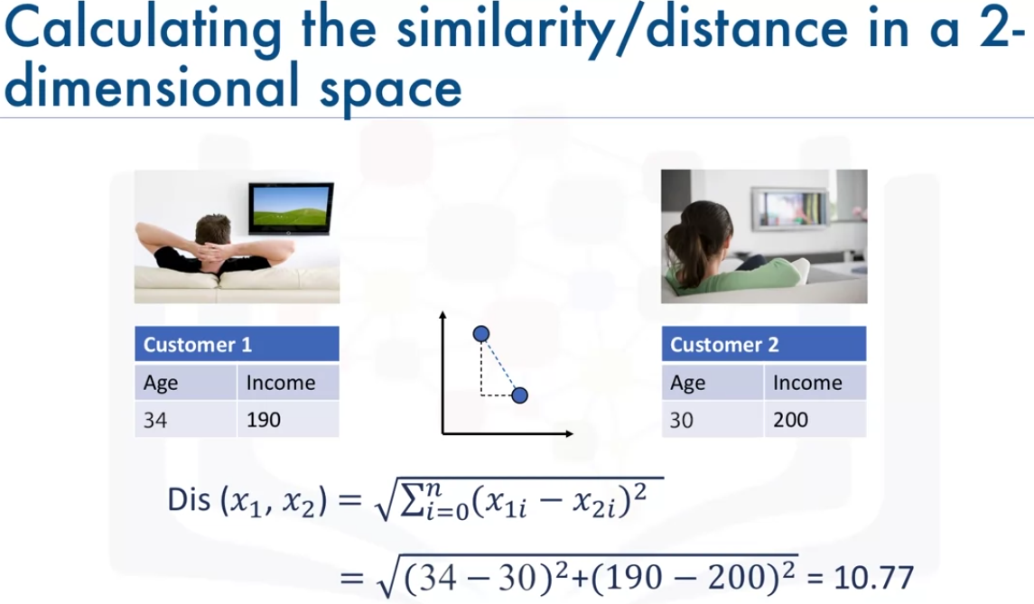

We can also use it for multi dimensional space but we have to perform normalization to ge the accurate dissimilarity measure.

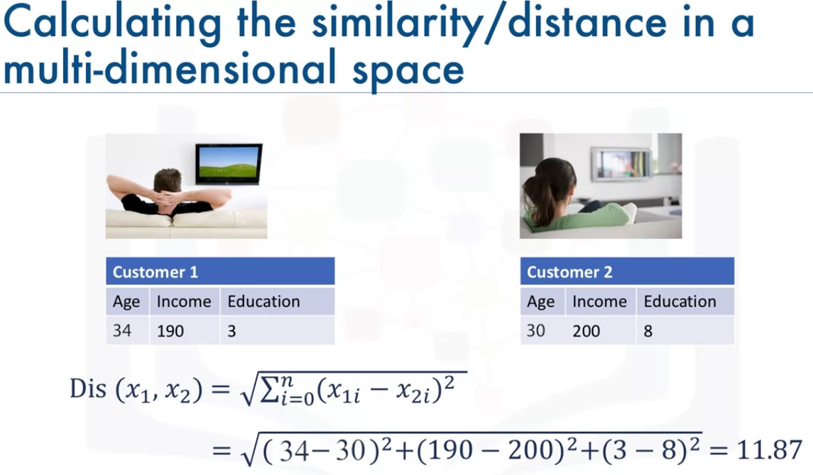

There are other variants for measuring the dissimilarity but it all depends on the datatype and the domain that the classification is done for it.

So how do we choose k?

if we choose 1 the nearest point is blue. This means Basic Service. This will be a bad prediction since more of the points around it are magenta or class 4.

Infact we can say that the blue in this case could be an anomly in the data. A low value of k causes a highly complex model aswell which might result in overfitting of the model. It means that the prediction process is not generalozed enough to be used for out-of-sample cases. The model cannot be trusted to predict properly.

if we choose very large k value for example like 20, the model becomes overly generalized.

So what is best k?

We need to reserve some testing data for finding the accuracy of the model. we can have k=1, k=2 ... and we can test the accuracy with these k values and plot it on the graph. then pick a k value which gives the best accuracy.

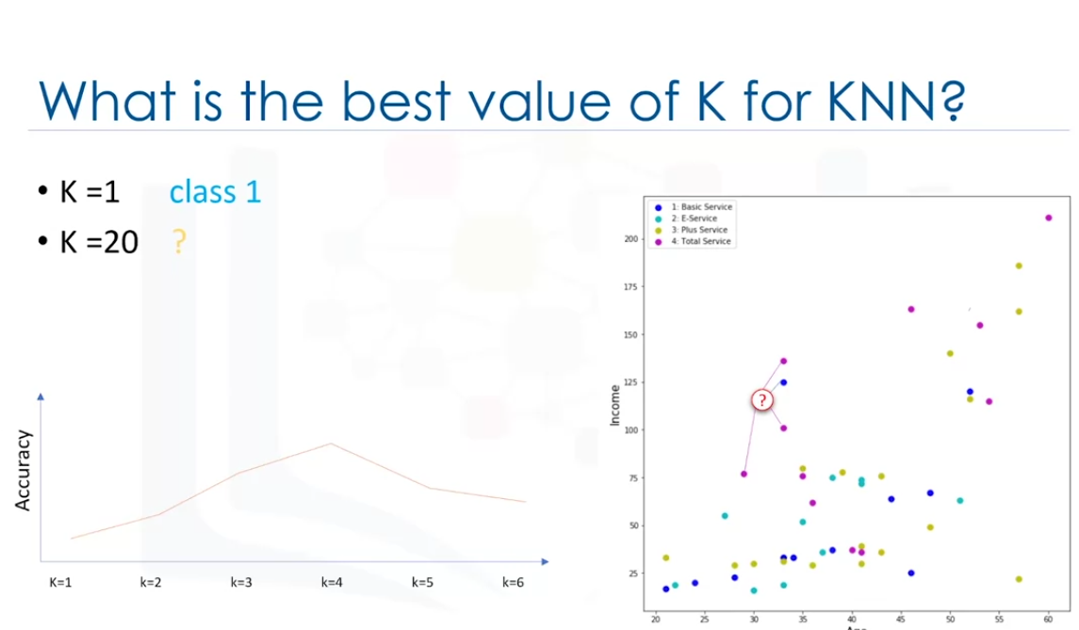

KNN can also be used to predict continuous varianle. In this situation, the average or median target value of nearest neighbors is used to obtain the redicted value for the new case.

For example lets say we are pridicting the price of a home based on its feature set, such as number of rooms, square foot, year of constructions, ... we can easily find the three nearest neighbors not only by distance but also similar features, then get a median of the prices to predict.

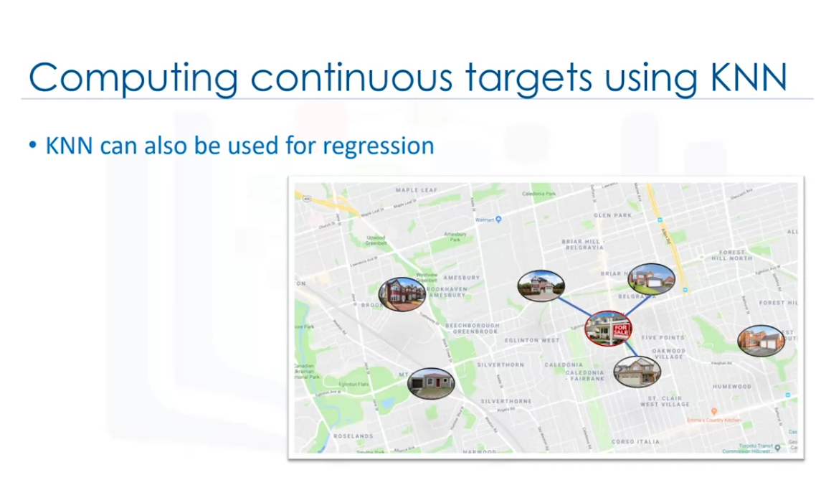

Classification Evaluation Metrics

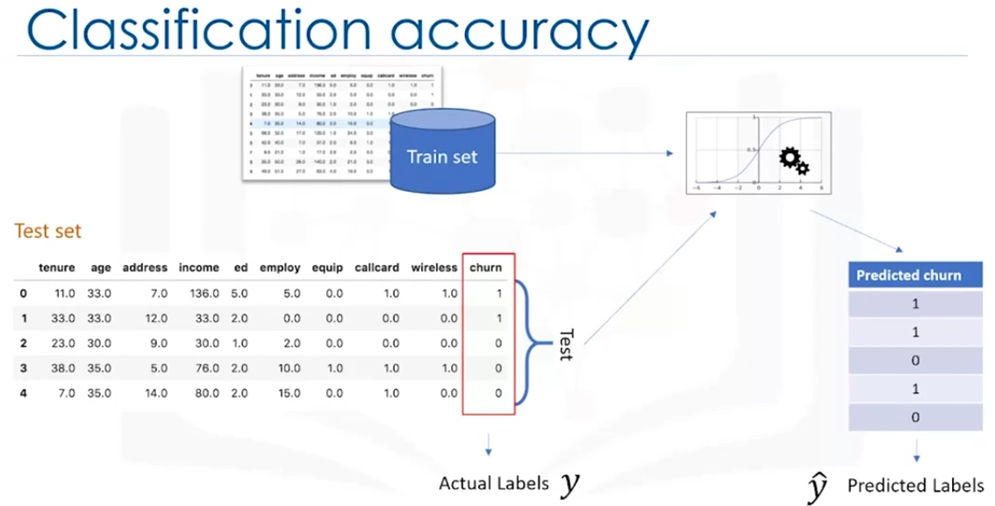

Evaluation Metrics tells how accurate the model is. Lets see Evaluation Metrics for classigication algorithms.

Lets take the Telecom dataset for customer churn. We trained the classification model and now we test the modek and get the predicted labels.

Now we compare thee predicted values with the actual values

There are different metrics . Some of them are:

jaccord Index

F1 Score

log loss

Jaccard Index orJaccord similarity coefficient.

Lets say u is the actual values and yhat is the predicted values. We can define Jaccord index as size of intersection divided by the size of the union of the label sets.

As seen in the image

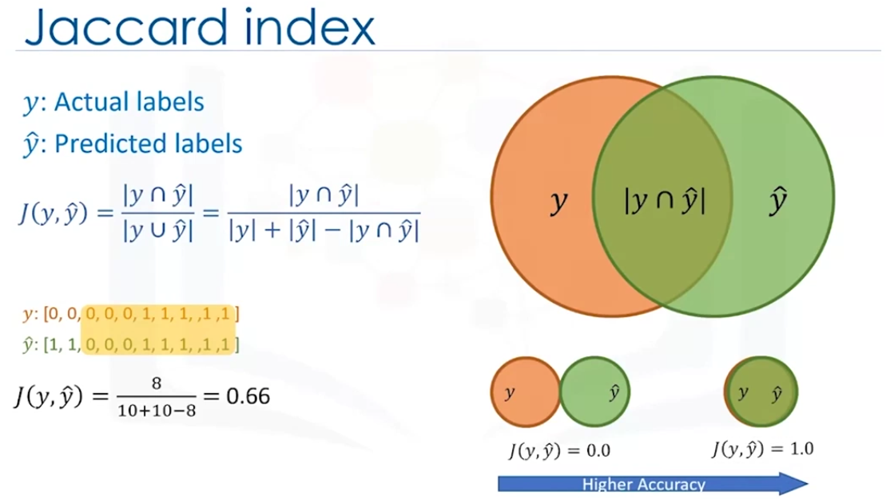

If the Entire set is matching then the index will be 1.0 and of none of it matches then 0.0. But this will never happen. if we get a value closer to 1.0 then the model has better accuracy.

F1-Score:

Another way to look at the accuracy is by looking at a confusion matrix.

Lets say our test set has only 40 rows, THe matrux shows correct and wrong predictions in comparision with actual labels

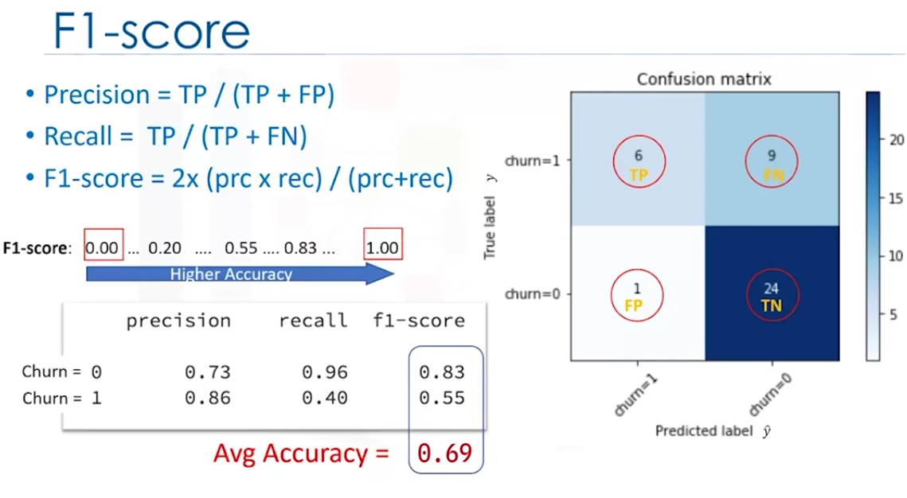

The rows show the Actual label and the columns show predicted labels.

The first row shows the churn value of 15 of them is one, and out of these the classifier predicted 6 of them as 1. But 9 of them were predicted wrongly. This can be considered as error.

We have 24 values with churn 0 in the actual set and the mode predicted 24 of them correctly.

The confusion matrix helps to show the correct and wrong predictions easily.

We can represent these values as counts of True Positive (TP), False Postive(FP), False Negative(FN) and True Negative (TN) when we have a binary classification.

We can use these to find the precision and recall using the ,formula in the above image.

Precision is a measure of accuracy provided that the label is predicted correctly.

Recall is the True positive rate.

We can find precision and recall of each class.

Then the precision and the recall are used to find the f1-score based on the formula in the image above.

f1-Score is the harmonic average of precision and recall.

We then find the average f1-score to find the accuracy of the model

Similar to the jaccard index, if we have f1 score closer to 1 then the model has a better accuracy.

Bothe Jaccard index and the F1-score can be used for muliple class classifiers. (Not covered in the course.)

Log loss:

Sometimes the classifier gives us the probability of a class label instead of giving us the exact class label.

For example in logistic regression, the outut could be probability of customer churn and this value could be between 0 to 1

Logarithmic loss also calle log loss calcilates the performance of a classifier which provides probability as its output.

For example, if the predicted probability is 0.13 where the actual value is 1, it means we have a bad prediction.

we can find the log loss for each value in the test set.

Then we average log loss to find the log loss of the whole model.

The model is good if we have a low log loss.

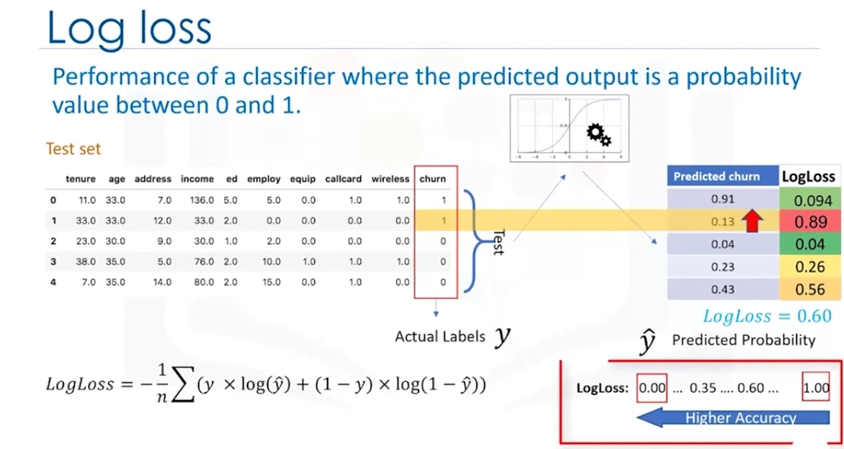

KNN Lab

Introduction to Decision Trees

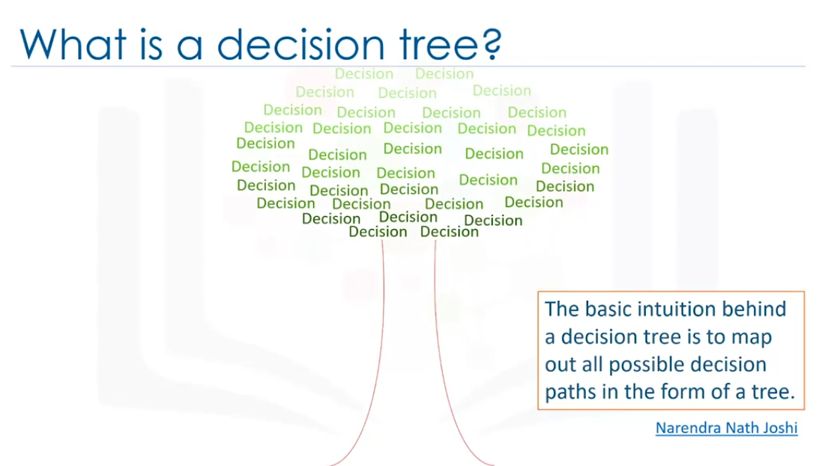

Let use medical data to find which drug to recommend. We have 2 drugs DrugA and DrugB.

Let bulid a model that predicts which drug to provide to the patient. The dataset contains age, gender, Sex, BP, Cholesterol and Drug(target). It is a binary classifier.

We can use the data to bulild a DecissionTreeClassifier to build a Tree and then use the model to predict the drug for new patient.

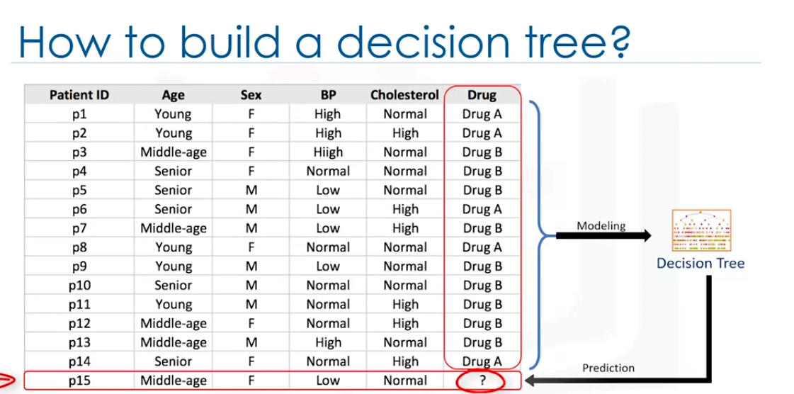

Decision trees are built by splitting the training set into different nodes where one node contains all of or most of one category of the data.

we can see the image shows a patient’s classifier.

We start withe Age which is divided into Young, Middle-age, Senior.

If the person is middle aged, we go the drug B.

If the person is young, then we check if check the Sex .

If the person is male then we use drug B. if female then drug A

If the person is Senior, then we check Cholesterol

if high cholesterol then we use drug A and if normal we use drug B.

In other words, we need to use more checks of the person is young or senior.

So decision tree work by testing a variable and branching on the result of the test to check model cases or reach a conclusion.

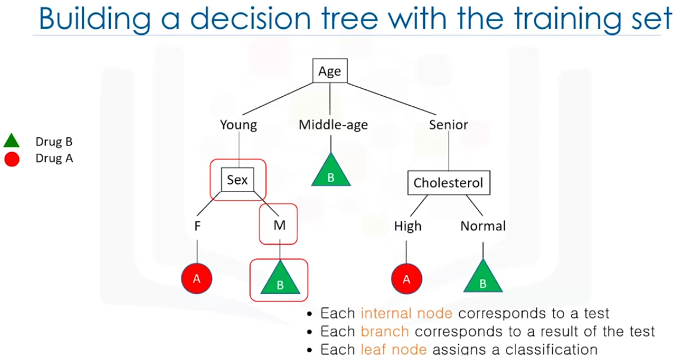

A decision tree is consructed by choosing an attribute one by one. We can follow these steps to create a decision tree.

Calculating the significance of the attribute chosen will be seen in the next video.

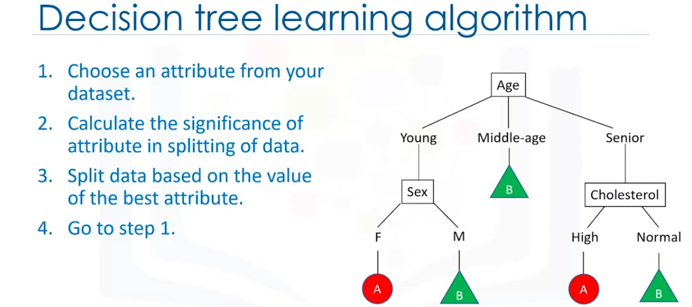

After building the tree we cand then predict the class label for unknown cases.

Building Decision Trees

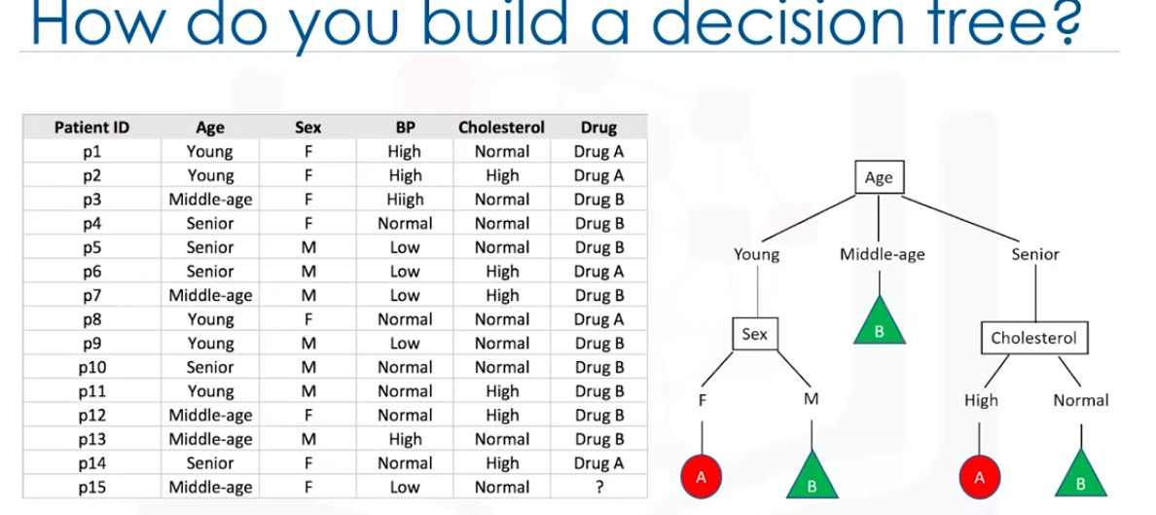

We use recurssive partitioning to classify the data.

Lets say we have 14 patients in the dataset. The algorithm chooses the most predictive deature to split the data on.

Which attribute to pick. Lets say if we pick cholesterol as first attriute to split the data.

It will split it into 2 branches High and low.

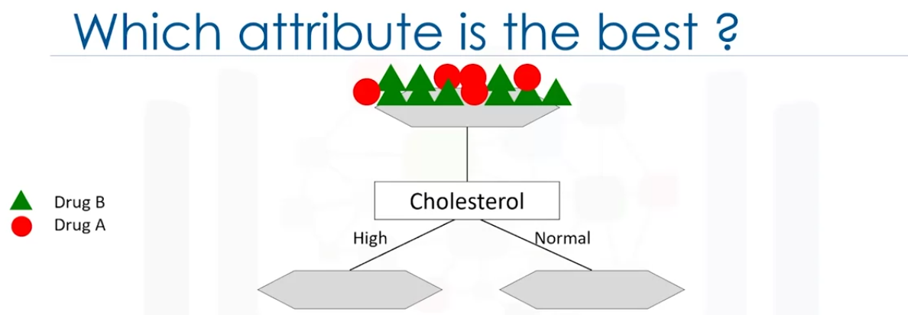

if the patient has high cholesterol, we cannot say with high confidence that the drug b be suitable for him. And if its normal, we still dont have sufficient info

Cholesterol is a bad attribute for split.

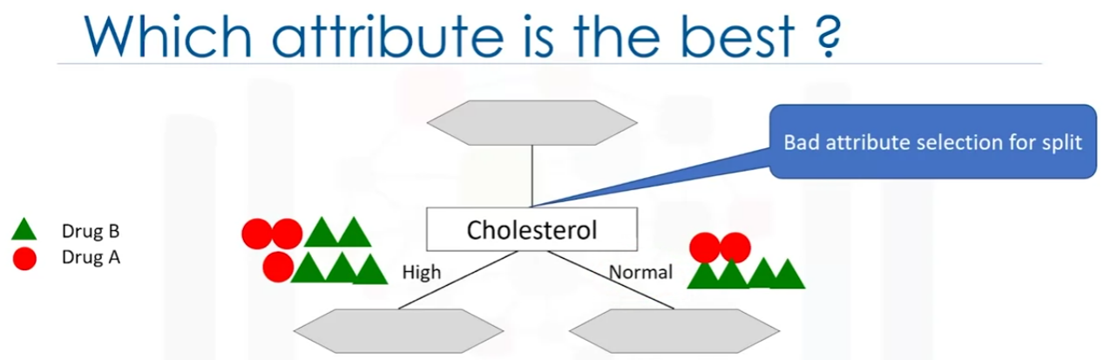

Lets try using Sex as the main attribute. We can divide it into Male and female. We can say Drug Be is suitable with high certainity. When it comes to male We dont have enough data. But it is still a better choice in comparision than Cholesterol. The Female branch has more pure nodes thatn the male branch. This means that the Sex attribute has more predictiveness , less impurities and lower entropy. Predictiveness is based on decrease in impurity of nodes. We are looking for the best featureto decrease the impurity of patients in the leaves after splitting them up based on that feature.

So Sex attribute is good candidate in this case.

So for male patients, we can check for further features, in this case we take cholesterol.

Now looking at the image below, we can say now if the male patient has high cholesterol, then we can prescribe Drug A. If not Drug b.

So choosing a note for splitting is very important.

we pick a feature that has high purity,

Pure node are nodes that has high number of values belonging to specific category rather than creating uncertainity.

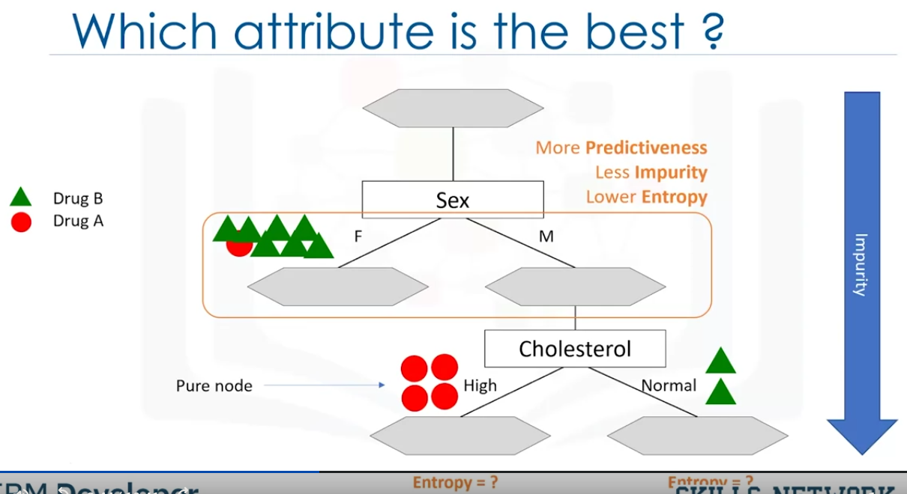

The process is repeated to get minimal imurity at each step.

Impurity is calculated by entropy of each node.

Entropy is a measure of uncertainty or randomness in a system. It quantifies the amount of information, disorder, or unpredictability associated with the outcomes of a random variable. Its meaning varies slightly depending on the context:

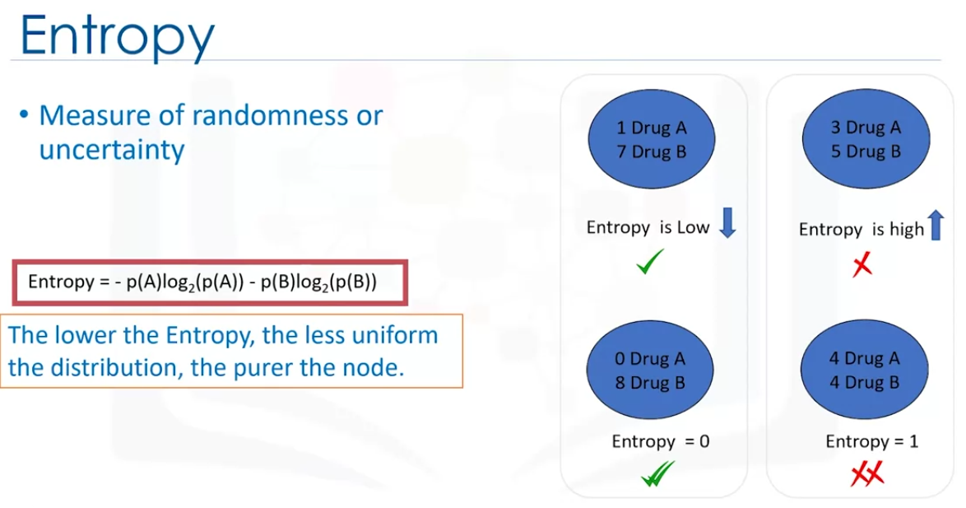

Entropy is the measure that calculates how much randomness is present in a node. We calculate enotropy for each feacture and pick the feature that has the minimun entropy.

Entropy is used to calculate homogeneity of the samples in that node.

if the sample is completely homogeneous, then the entropy is 0. If equally divided it has an entropy 1.

You can use the frequency table to find the entropy using the formula in the image above.

We have libraries that calculates these entropies.

Example:

We have 9 Drug B and 5 drug A when the data is not split and the entropy is 0.940. Let split the data by choosing an attribute.

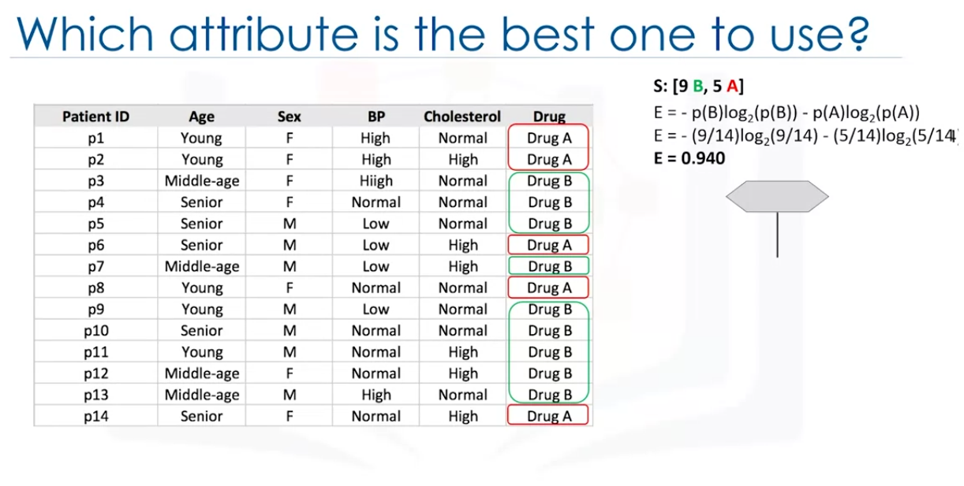

If we choose cholesterol to solit the data there are 6 Drug B and 2 Drug A for normal Cholesterol and 3 Drug B and 3 Drug A for High Cholesterol.

The entropies are 0.811 and 1.00 respectively which are not good. So this attribute is not a good choice.

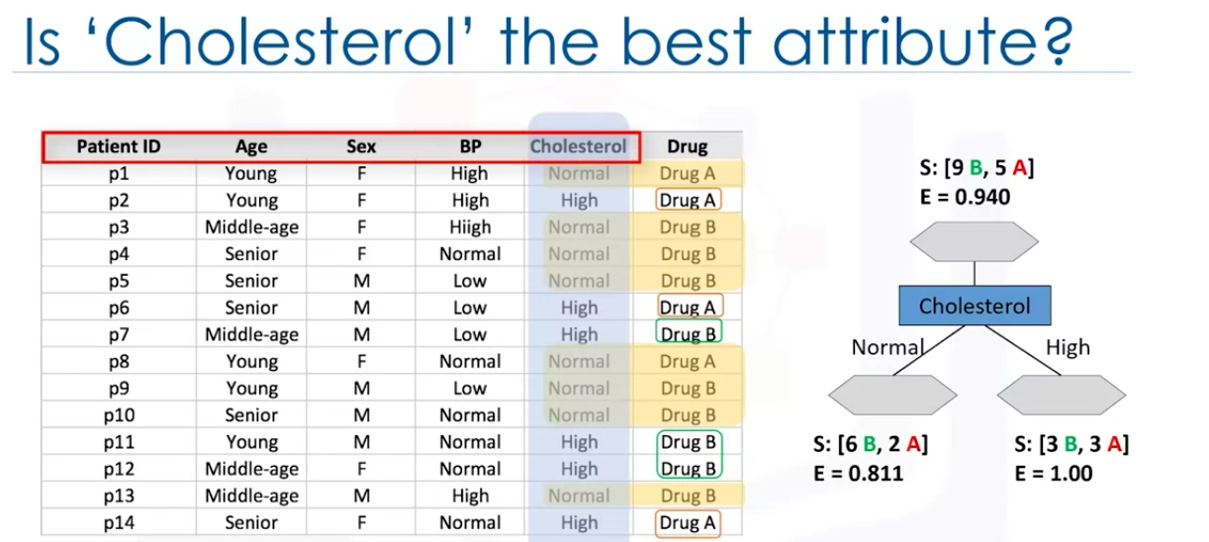

Now lets take the Sex column. For demale there are 3 Drug b and 4 Drug A. For male there are 6 Drug B and 1 Drug A. thr entropies are 0.98 and 0.92 respectively. 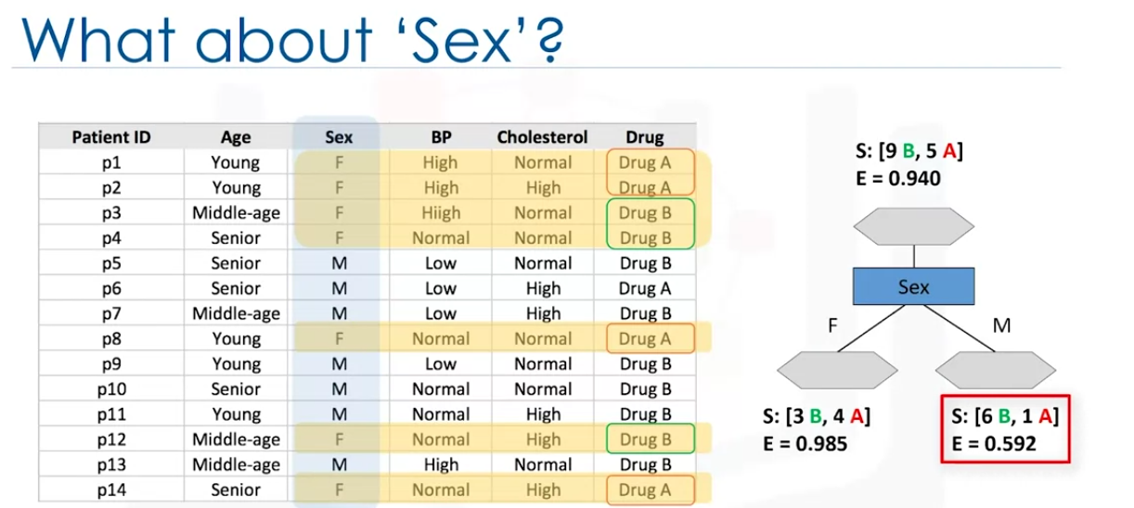

We need to pick a tree that has a higher information gain after splitting.

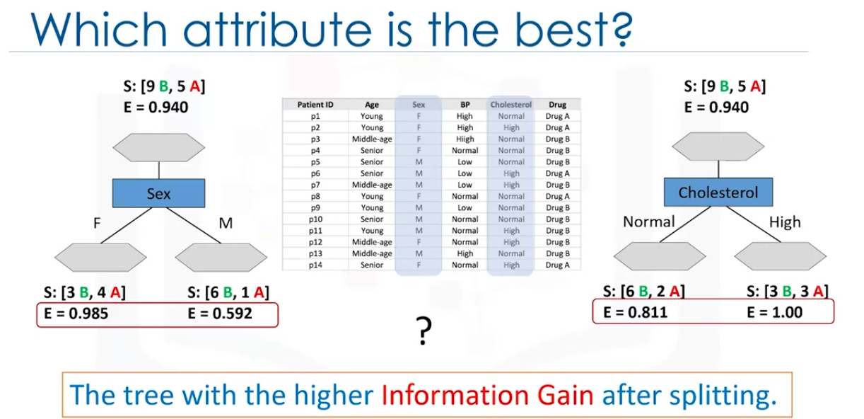

We can think of entropy and information gain as opposites.

Entropy measures the amount of randomness

information gain measures the certainity increases

Constructing a decision tree that has the high information gain.

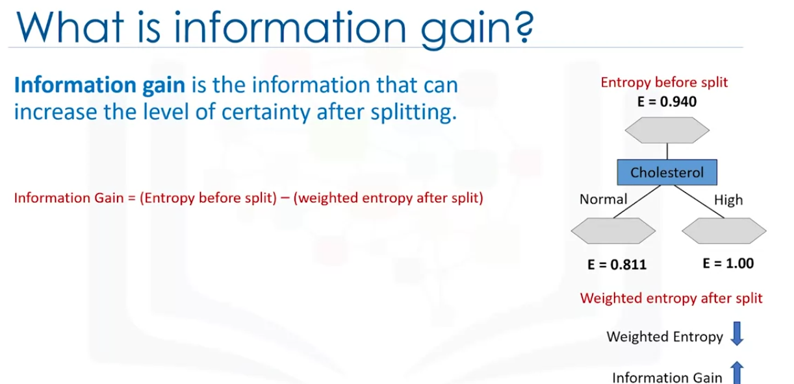

We can see in the below image by calculating the information gain, we get 0.151 for the Sex attribute and 0.048 for the Cholesterol.

So Sex attribute is more suitable.

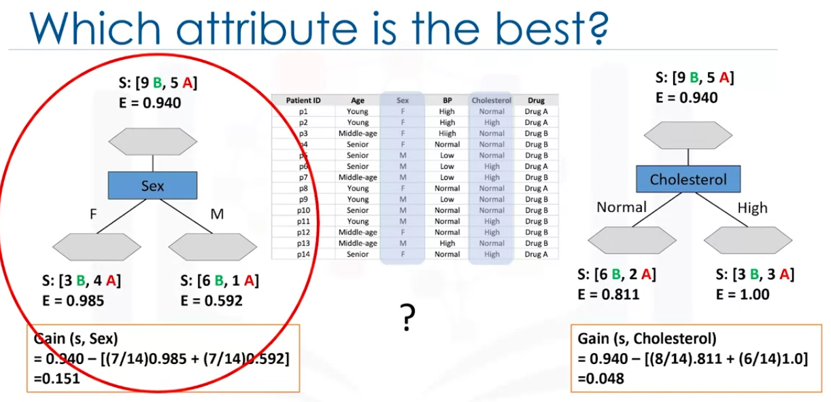

Then we can repeat the the process to find the next attribute. and keep building the tree thill we get pure nodes.

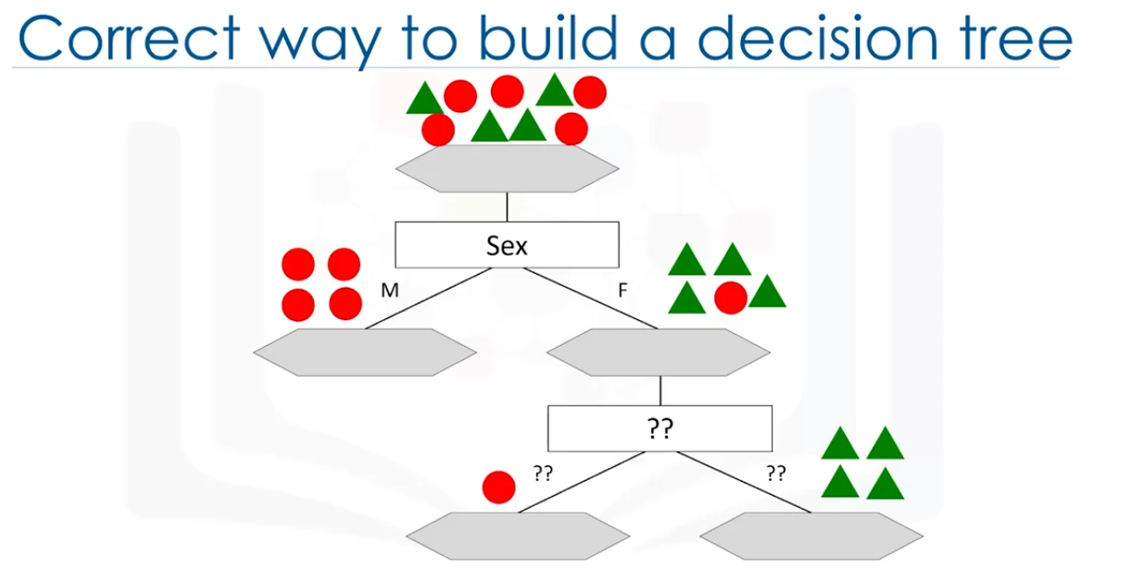

Decision tree lab

Regression Tree

As we have already seen, decision trees can be used for classification, but we can also use them for regression, commonly called regression trees.

The basic idea behind regression trees is to split our data into groups based on features, like in classification, and return a prediction that is the average across the data we have already seen.

Consider the housing data below, where we are using the ‘Age’ to predict the ‘Price’ of a house.

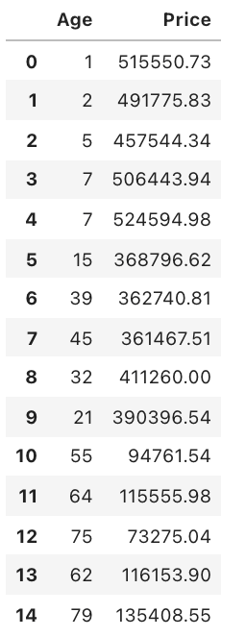

Here, we can see the difference age has on the house prices. Ages between 0 and 10 have an average price of approximately $500,000, ages between 10 and 50 have an average price of approximately $380,000 and houses older than 50 years have an average price of approximately $100,000. Using these general ranges, we can predict the price of a house.

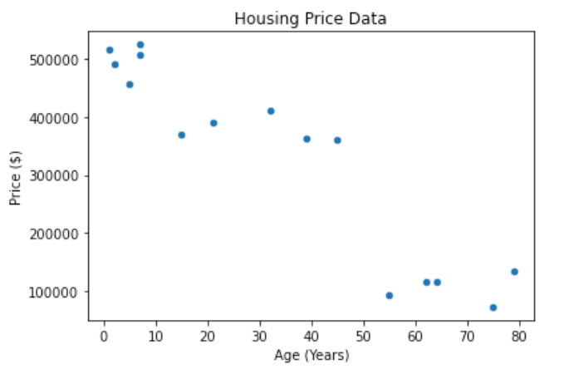

Using the data above, we can create the regression tree, as shown below. The prices were determined by calculating the average price of the houses in the age range.

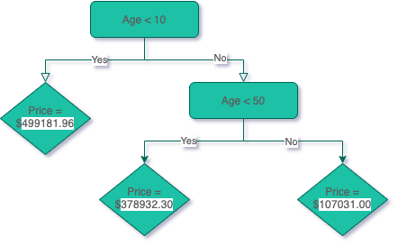

As you can see, we use the features to group the houses and then calculate the average price across these groupings.

Criterion

The way the trees are built are similar to classification, but instead of using the entropy criterion. In Classification Trees, we choose features that increase the information gain. In Regression Trees, we choose features that minimize the error.

A popular one is the Mean Absolute Error, which we have also seen previously.

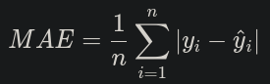

How Regression Trees are Built?

Take the dataset sample shown below, the first step is to decide what the first decision is. We will do this by using the criterion and checking every single feature in the dataset to see which one produces the minimal error.

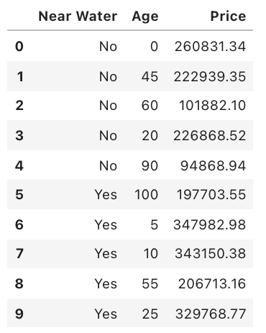

Categorical Features

Categorical features are simple, here we have Near Water so all we need to do is calculate the error if we used this as the first feature. Near Water feature has two categories: ‘Yes’ and ‘No’, therefore, we must calculate the average ‘Price’ of houses in the ‘Yes’ and ‘No’ categories. Then we use those values to calculate the average error.

‘No’ Category:

Index of Houses in ‘No’ Category = [0, 1, 2, 3, 4] Prices of Houses in ‘No’ Category = [260831.34, 222939.35, 101882.1, 226868.52, 94868.94] Average House Price in ‘No’ Category = 181478.05 Absolute Error = [79353.29, 41461.30, 79595.95, 45390.47, 86609.11]

‘Yes’ Category:

Index of Houses in ‘Yes’ Category = [5,6,7,8,9] Prices of Houses in ‘Yes’ Category = [197703.55, 347982.98, 343150.38, 206713.16, 329768.77] Average House Price in ‘Yes’ Category = 285063.77 Absolute Error = [87360.22, 62919.22, 58086.61, 78350.61, 44705.00]

MAE

This is the MAE of the Near Water feature, and this number will be used to compare against MAE of all other features to determine which one is the lowest. Therefore, it will establish the first decision in our regression tree.

MAE = 66383.17

Numerical Features

Numerical features, like ‘Age’, are trickier to handle because we need to find a number, instead of using a category, to split the data by. We do this by creating a boundary between each point, then we calculate the error.

For example, first we create the boundary between the first two data points, which are (0, 260831.34) and (5, 347982.98), so we create a boundary of x = 2.5 (The midpoint between the x component of the first two data points). We now find the average price of the houses on the left and right sides of this boundary and use it to calculate the MAE.

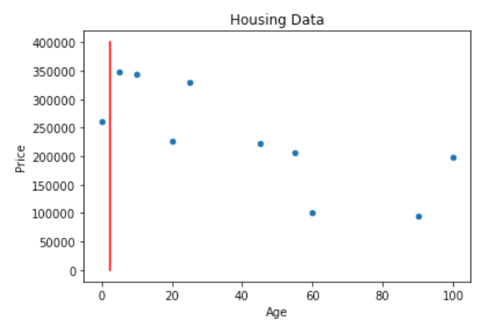

Left:

Index of Houses on the Left Side = [0] Prices of Houses on the Left Side = [260831.34] Average House Price of Left Side = 260831.34 Absolute Error = [0]

Right:

Index of Houses on the Right Side = [1, 2, 3, 4, 5, 6, 7, 8, 9] Prices of Houses in the Right Category = [222939.35, 101882.1, 226868.52, 94868.94, 197703.55, 347982.98, 343150.38, 206713.16, 329768.77] Average House Price in the Right Category = 230208.64 Absolute Error = [7269.29, 128326.54, 3340.12, 135339.7, 32505.09, 117774.34, 112941.74, 23495.48, 99560.13]

MAE

Now we can find the MAE, using the absolute errors from the left and right sides.

MAE = 66055.24

Further Steps

This process is then repeated for each boundary between each pair of consecutive points.

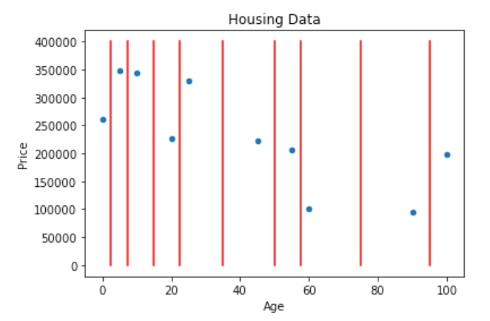

This results in the following MAE for each boundary:

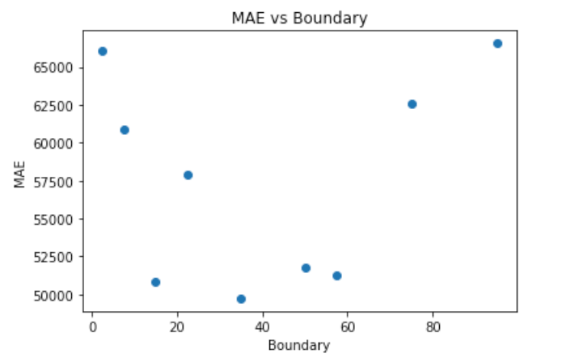

Where the values for the points are:

(2.5, 66055.24) (7.5, 60871.09) (15, 50847.52) (22.5, 57918.2) (35, 49726.55) (50, 51792.86) (57.5, 51288.06) (75, 62616.49) (95, 66568.42)

We can see that the boundary 35 results in the lowest MAE in this feature.

Choosing the Decision

Now, we compare the categorical MAE and the lowest numerical MAE, in this case, the categorical is 66055.24, and the numerical is 49726.55. So, for the first decision, we will use the numerical ‘Age’ feature. We end up with a regression tree that looks like this:

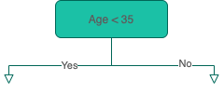

When do we Stop?

With the regression tree above, we have two options, we can either stop here and use the average value of the ‘Yes’ (left) and ‘No’ (right) to predict the house prices, or we can continue to add more decisions to either branch. There are a few conditions that are commonly used to stop growing regression trees:

• Tree depth • Number of remaining samples on a branch • Number of samples on each branch if another decision is made

The depth of the tree above, is 1, because there is a single decision and the number of samples on each side is 5. Let’s add more decisions until the depth of the tree is 2. First, we start with the ‘Yes’ (left) side and we calculate the MAE for the features using the houses that have ‘Age’ < 35.

Adding Decisions

Left

Like before, we use the Near Water feature and calculate the MAE on houses with index 0, 3, 6, 7, and 9.

Categorical Features

MAE = 11005.34

Numerical Features

Now, we find the MAE for the boundaries in the ‘Age’ feature.

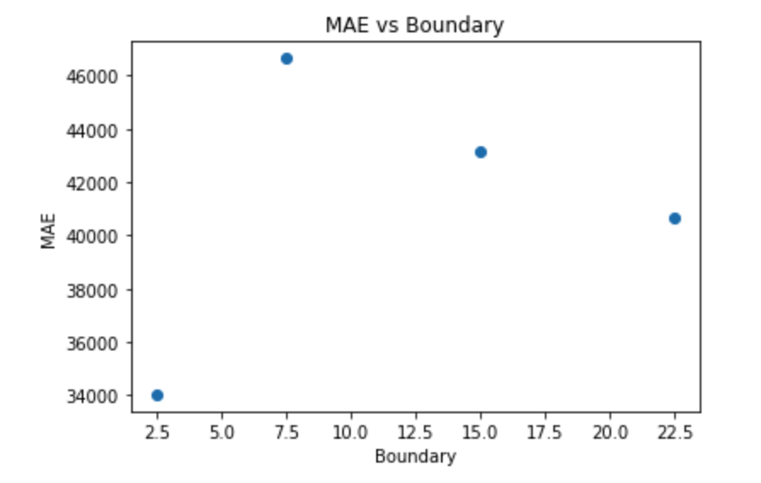

We can see that the Near Water feature causes the MAE to be lowest on the ‘Yes’ (left) side of the regression tree, so we will add a decision for the Near Water feature.

Right

Now we will find the features that result in the lowest MAE from the houses with index 1, 8, 2, 4, and 5.

Categorical Features

MAE = 35018.94

Numerical Features

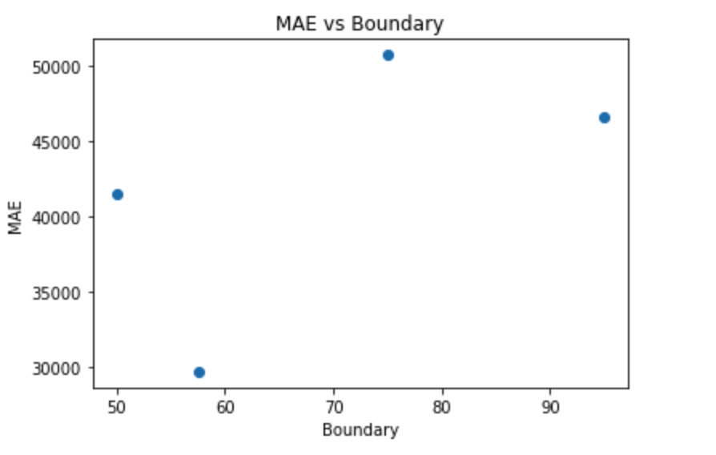

Here, we can also see that the ‘Age’ feature will result in the lowest MAE with the boundary set to 57.5, so on the ‘No’ (right) side of the tree, we will add another decision for the ‘Age’ feature.

Final Result

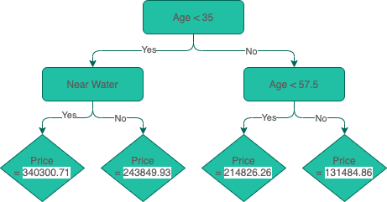

Regression Tree Lab

Faster Taxi Lab